1. **Creating a destination in the BTP cockpit using Northwind:**

* Click on **Destinations** from the left menu under **Connectivity** and click on **New Destination.**
* Enter the following information;

Name: **Northwind**, Type: **HTTP**

Description: **Northwind OData services**, URL: [**https://services.odata.org/V3/Northwind/Northwind.svc**](https://services.odata.org/V3/Northwind/Northwind.svc)

Proxy Type: **Internet**, Authentication: **NoAuthentication**

* Click on **New Property** and add these properties:

**HTML5.DynamicDestination : true sap.applicationdevelopment.actions.enabled : true**

**sap.processautomation.enabled : true WebIDEEnabled : true**

* Then Check the connection

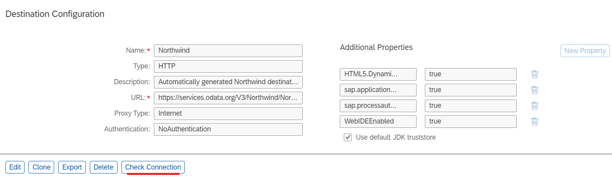

* Go to **Build homepage, Settings, Destinations,** click on **New Destination** and add your destination.

1. **Sales Order Management Tutorial:**

* This is a tutorial of a business process, an automation that is also supported by actions from the backend. This business process starts with an order processing form which requires minimal information from the user and the remaining ones are fetched by the agent from an excel spreadsheet. It then goes through the normal process of approval or rejection of the order whether automatically or manually from the supplier’s side according to some standards that are set by us.
* Go to **Build homepage**, click on **build automated process** and choose **business process** and set a name for your process.
* In our created process, we’ll start by creating a **form** to trigger the business process, we choose the items we want from the left menu and drag-and-drop it on the right side onto our form. In our case we choose only these two items.

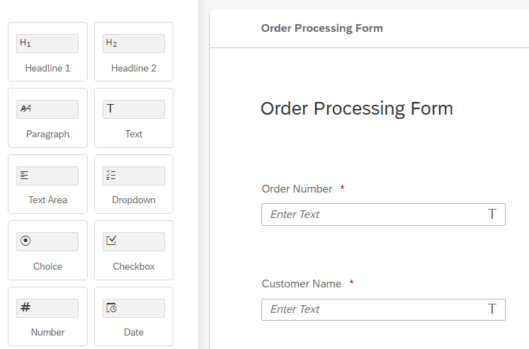

* Then we go to make our automation **Get Order Details**, which simply gets the remaining order details from an excel spreadsheet on our desktop and returns the information according to the order number entered to it, to the process so the whole process continues running smoothly.
* The Excel spreadsheet will be on the github along with this document.
* We put the **Open Excel Instance,** to open excel on our desktop. Then we put the **Excel Cloud Link,** this activity converts excel type to the data type of our choice which will be **Sales Order.**

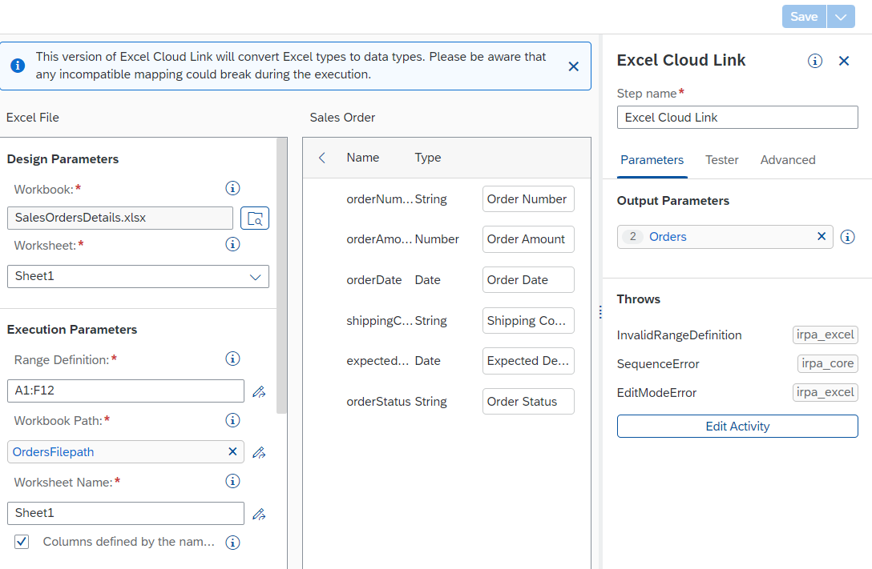

* Then we put **Close Excel Instance** and **Create Sales Order Variable.**
* After this we start a loop where we try to find the order number given to us from the form in the business process by checking if it equals the number we’re at in the loop currently, and when we get it we set it as **SelectedOrder variable** and end the loop.
* We output a message with the selected order just for us while testing.
* **Get Order Details Automation Overview:**

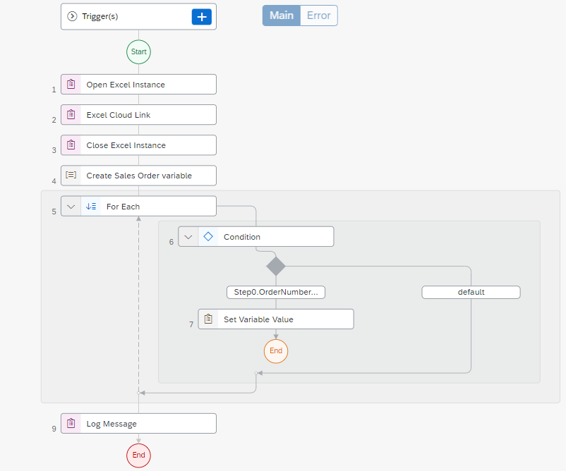

* We go back to the process and make a condition to check if the order amount is less than 1000

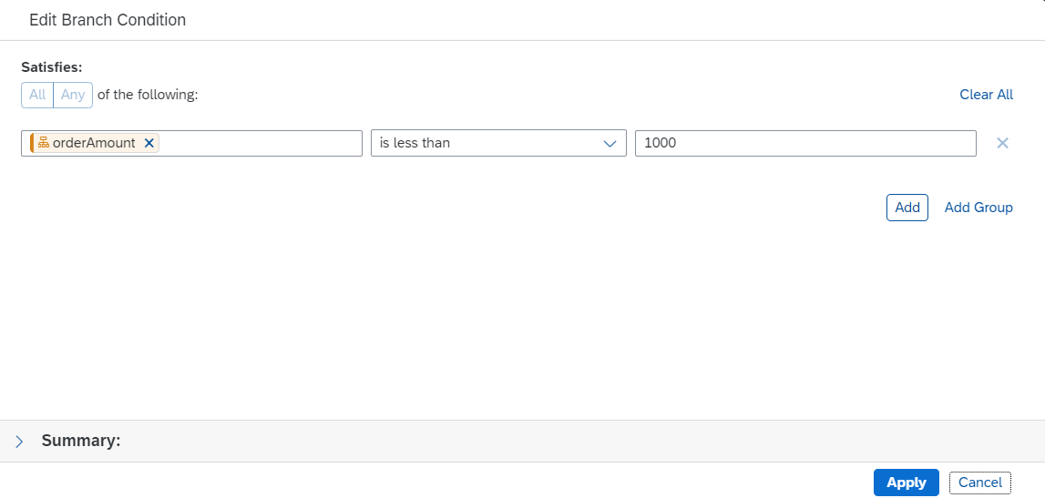

* Then we’ll make an **Automatic Approval Notification Form.** It will look like this.

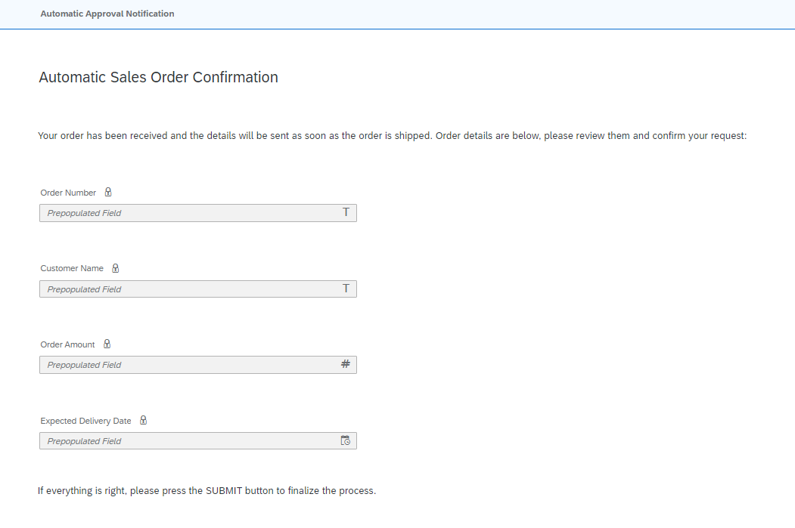

* Otherwise we will make an **Approval Form (Supplier),** to get an approval from the supplier’s side and it will look like this.

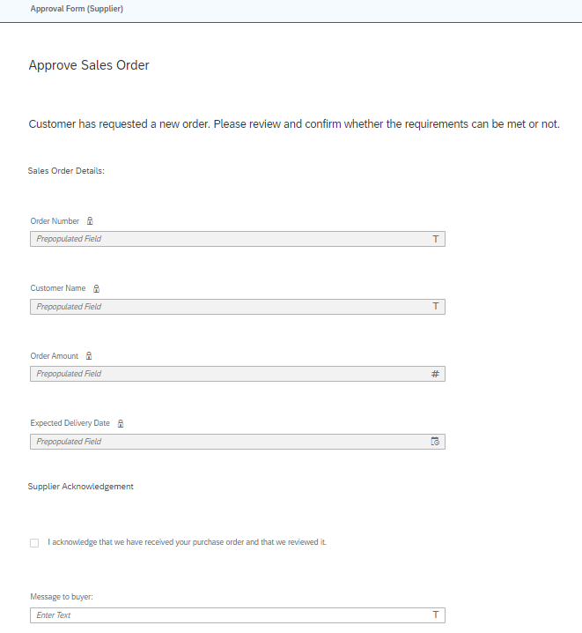

* We have two cases here, one a **Sales Order Notification (Approved)**

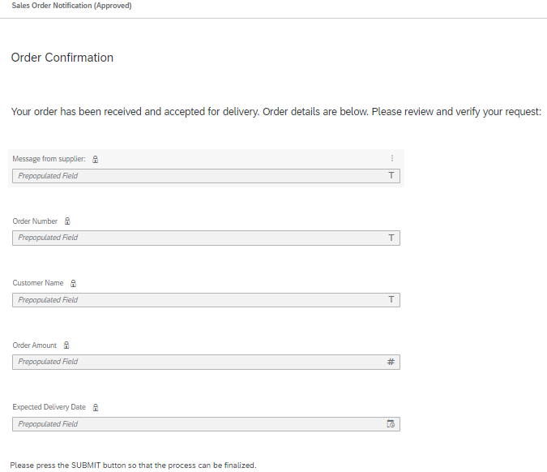

* The other case, a **Sales Order Notification (Rejected)**

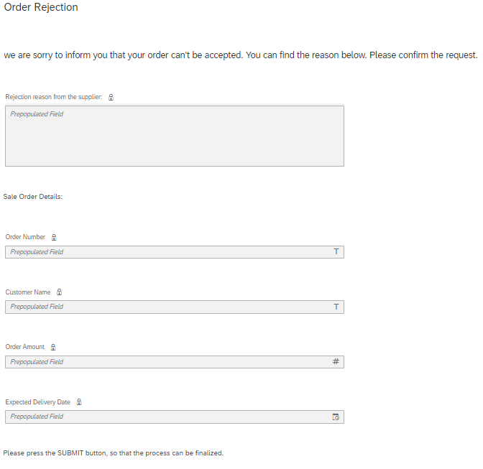

* Then we end the process.
* **Process Overview:**

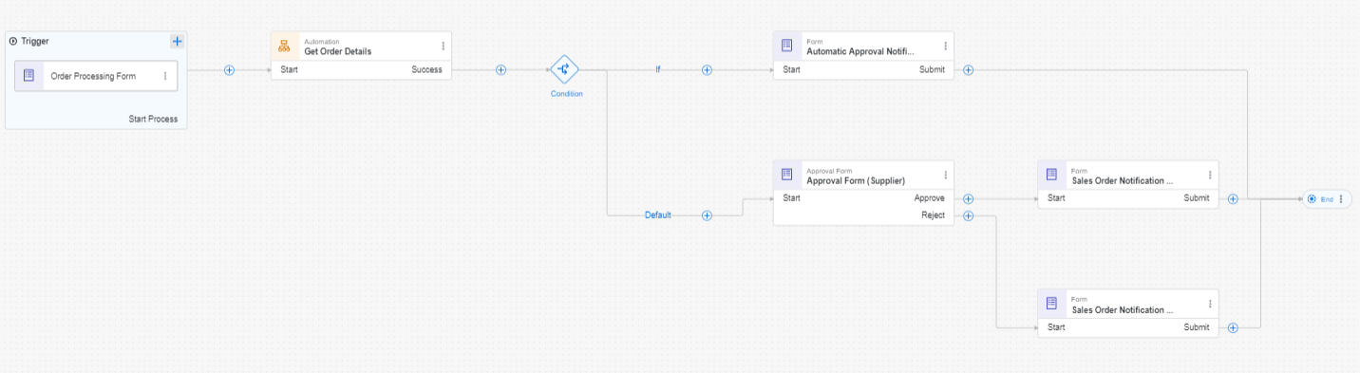

* We’ll now go to **Build homepage** again and click **build automated process,** choose **actions.**
* Select **Upload API Specification** and upload the Northwind.json file that’s on github.
* When you see the pop up of add actions, search for **get entities from territories** and add it.
* Go to **output** tab and tick on the word that’s expandable and has “array” beside and this case, value then on the right side from the tags’ dropdown select **Main Output Array.**

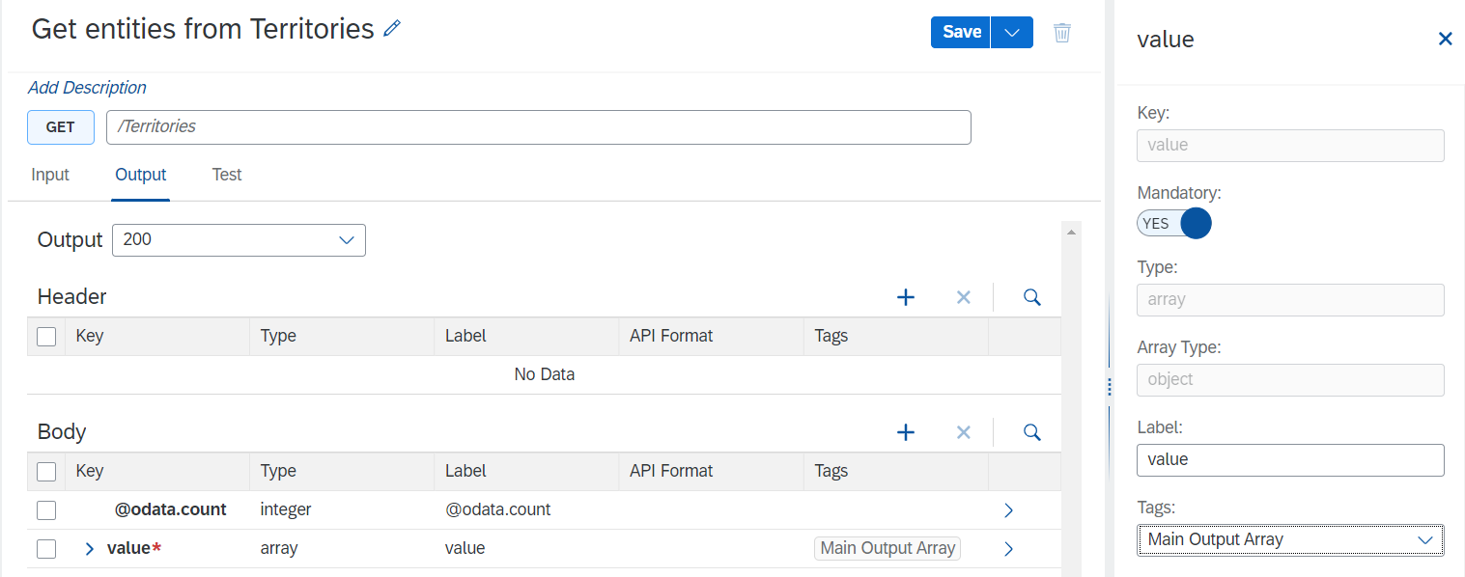

* Click **Save**, **Release and Publish to the library.**
* Go back to the Sales order management business process we made, go to the **Order Processing Form,** add a drop down, choose **from data set,** choose the data source **the action we just made,** for the destination variable create one, name an identifier, a description and the type is destination. For available date choose a variable for your data.
* **Save, Release and Deploy.**